Automation script to scroll web page

Step-1 here go to file select NEW>MAVEN PROJECT

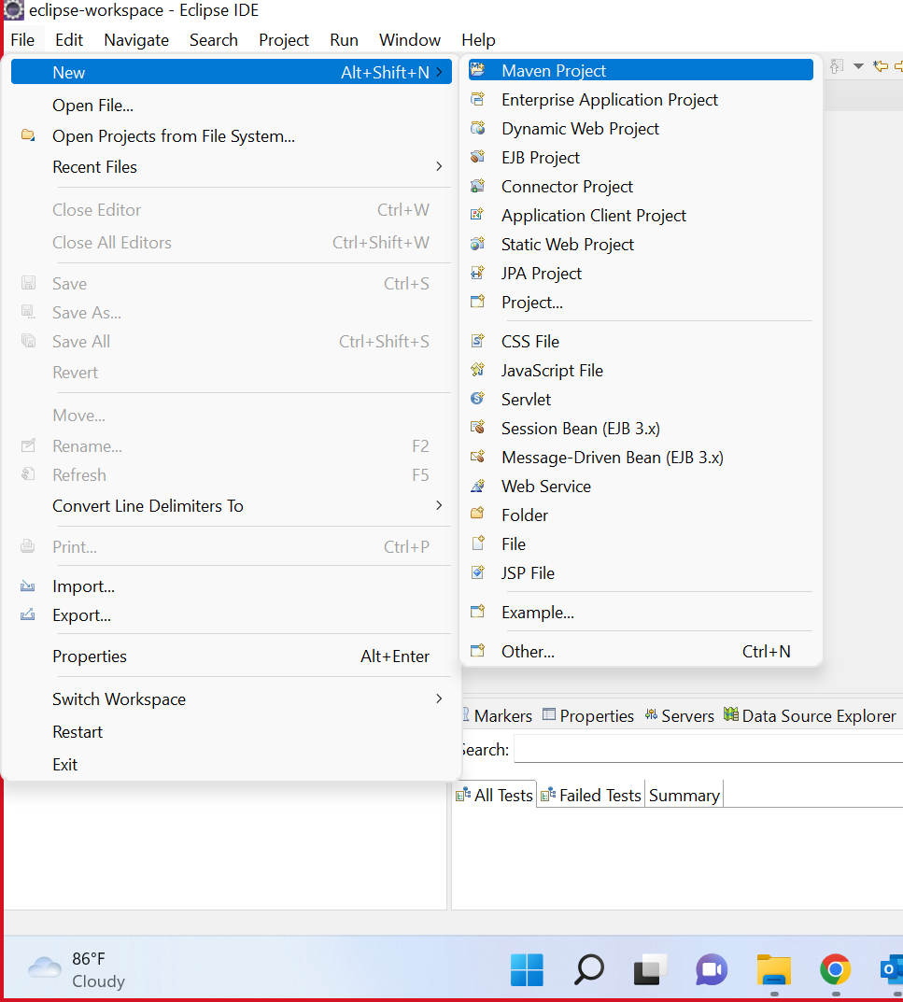

Step-2 check the create the sample project

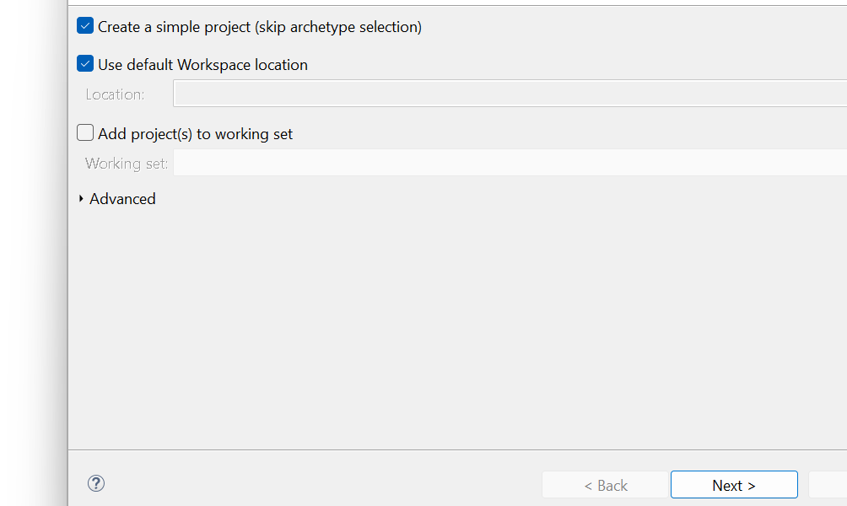

Step-3 select the com.tester>new>class

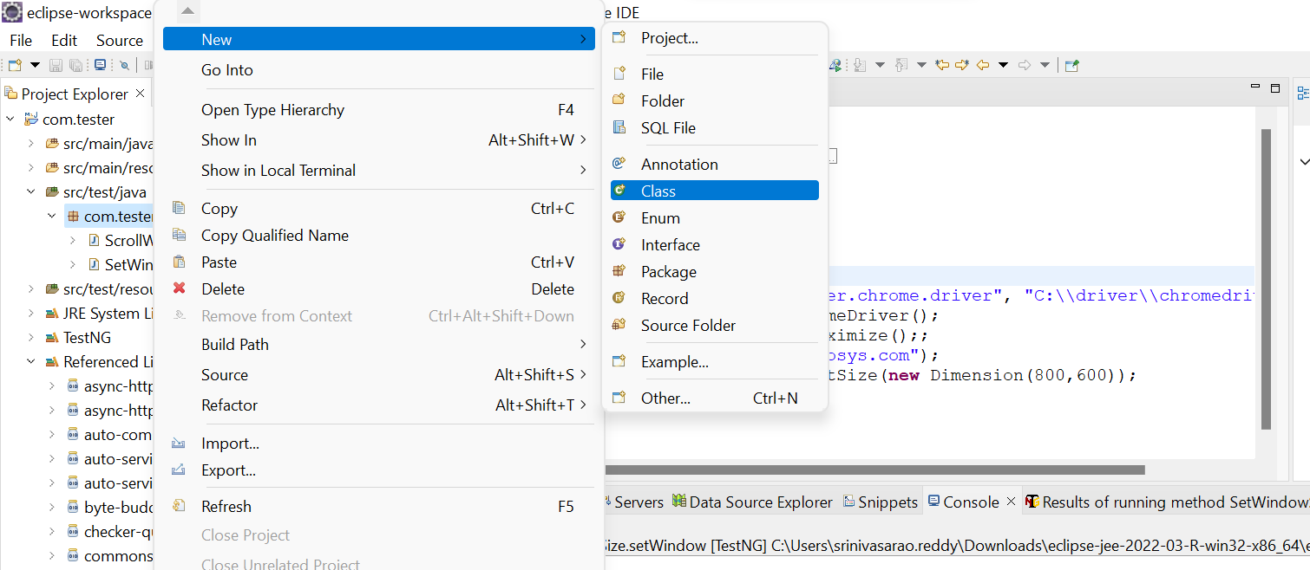

Step-4 after the step-3 it will ask the group id and artifact id

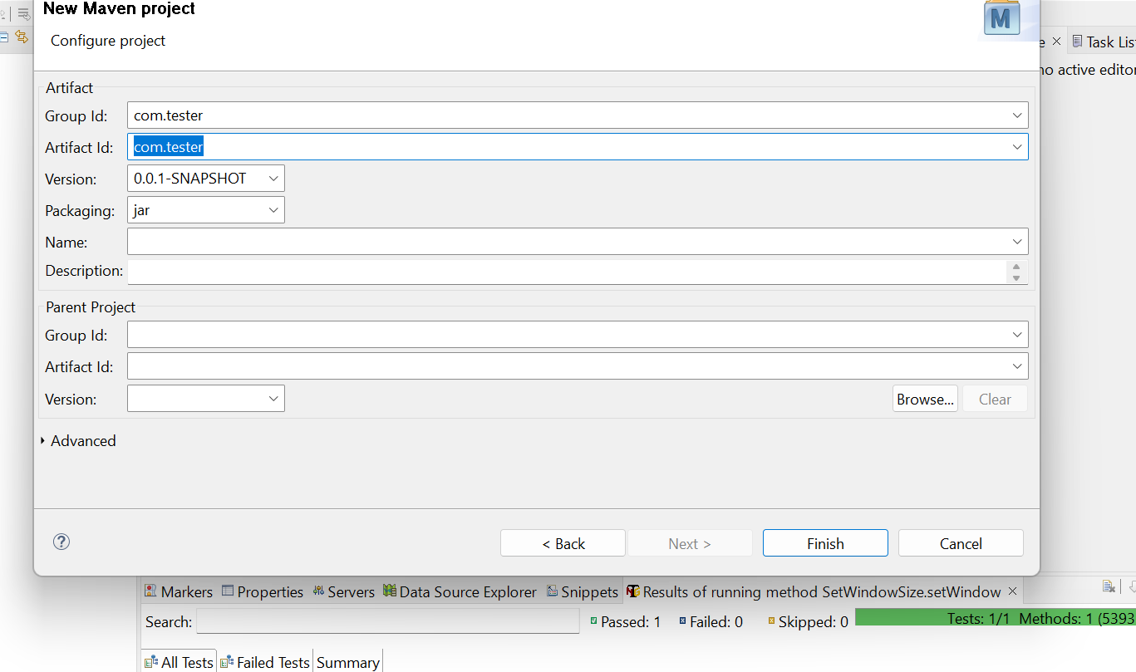

Select the com.tester of main subject java buildpath and add external jars of the library files

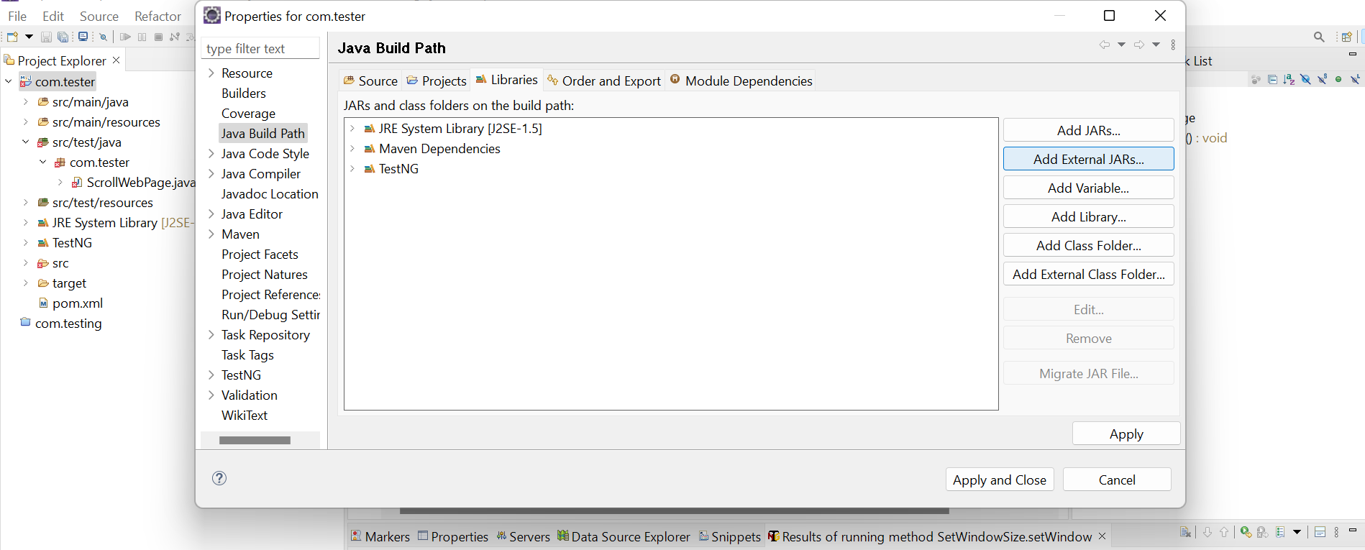

Select the src/test/java>class

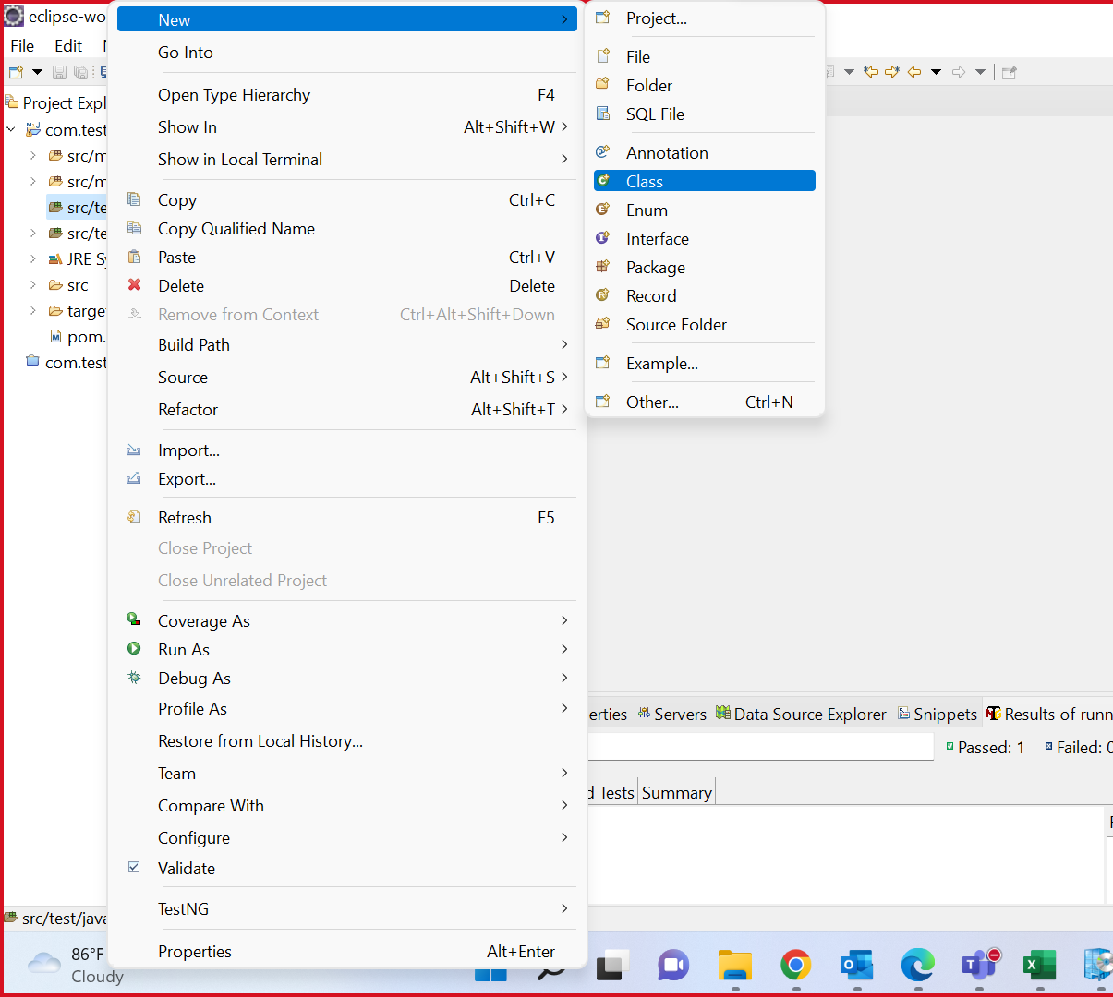

Mention the name u want the name

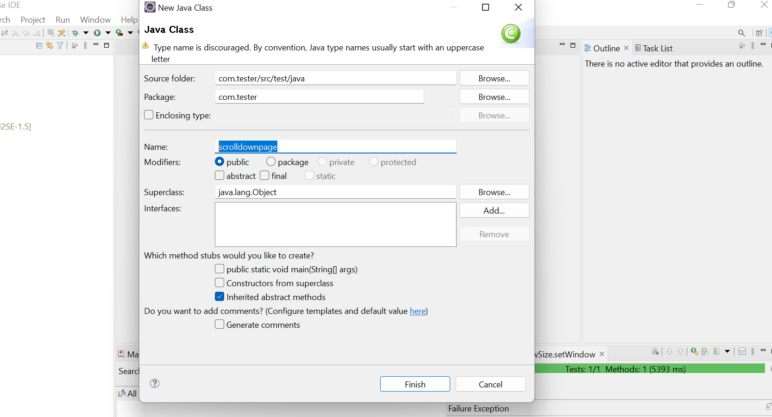

Select and paste the code and save it and run

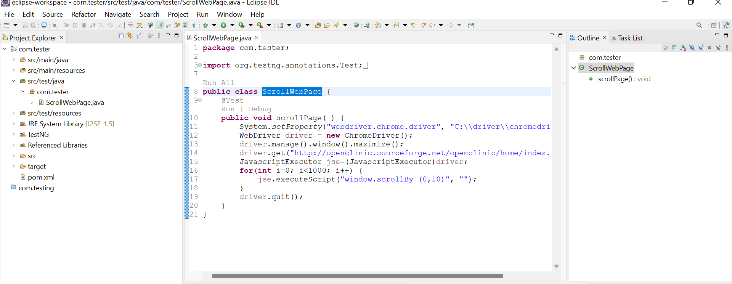

It is the webpage of the openclinic

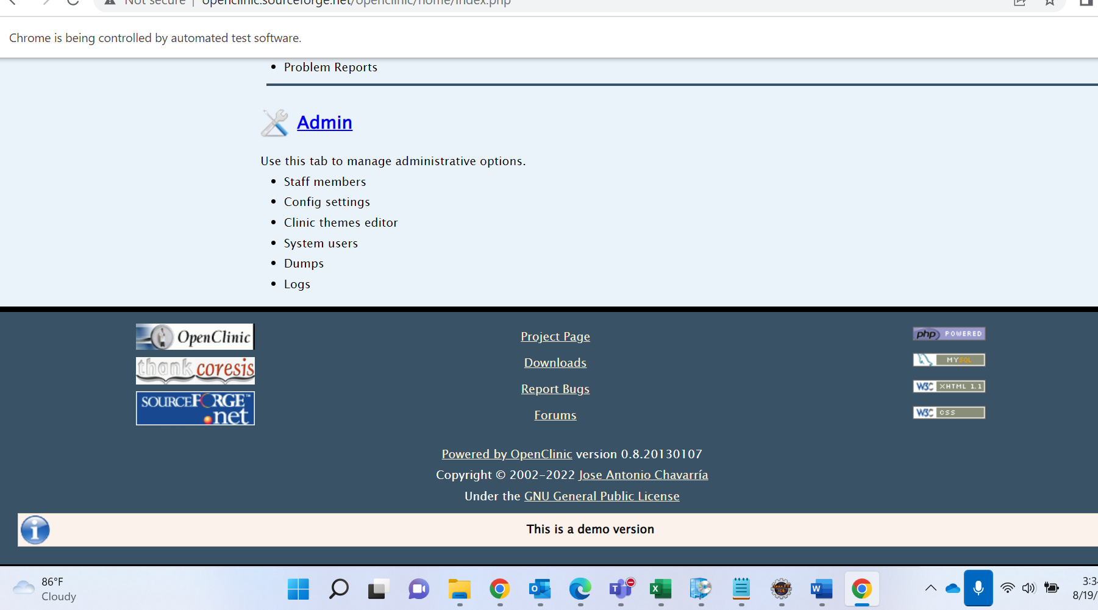

This shows the code is pass

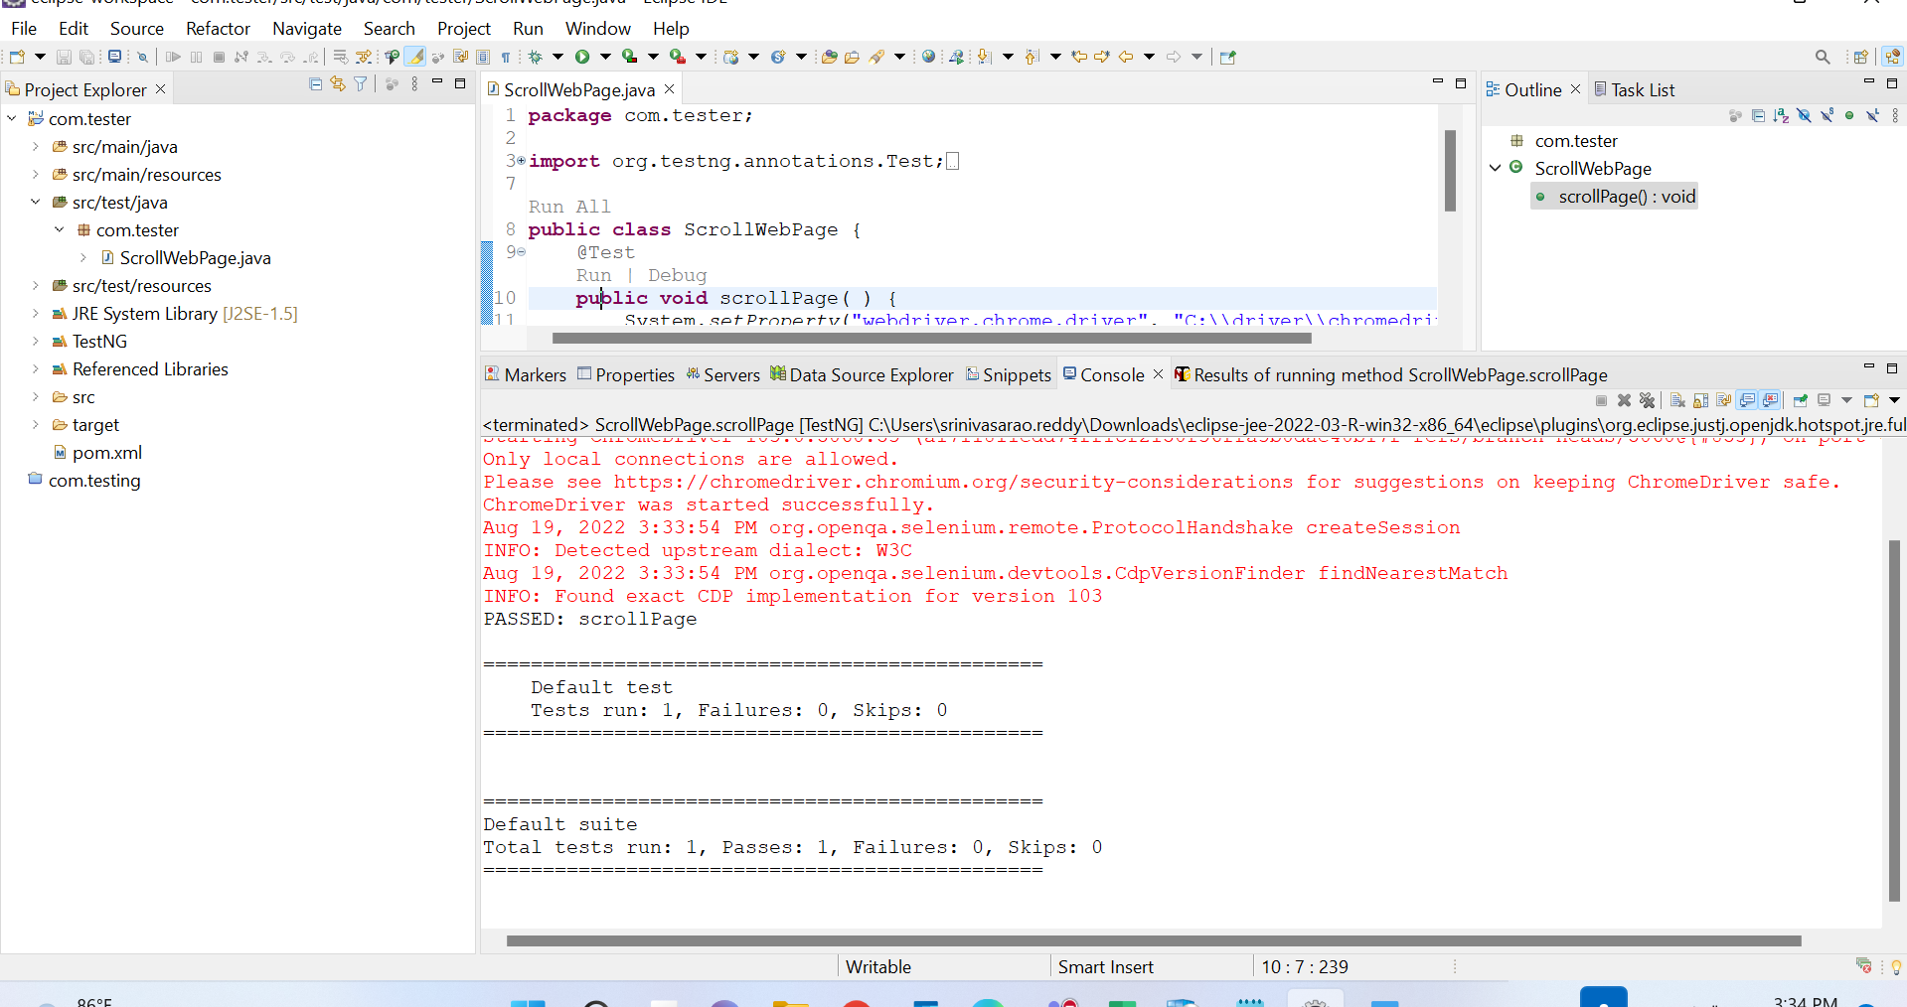

For run the code of selenium u need to install

Eclipse IDE -- Software center

2. TestNG -- help > Eclipse Marketplace > search testng

3. Selenium -- Infyme Software center

4. Chrome Driver -- Infyme Software center

5. JDK version 8 -- Software Center